A000-Mex-Colima-Dog-Ceramic-Burnished, Deep Red-300 BCE-300 CE

**Itzcuintli Xochiocoyotl**

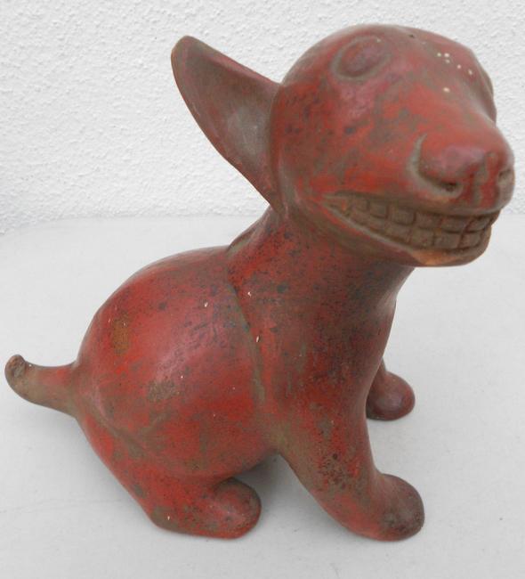 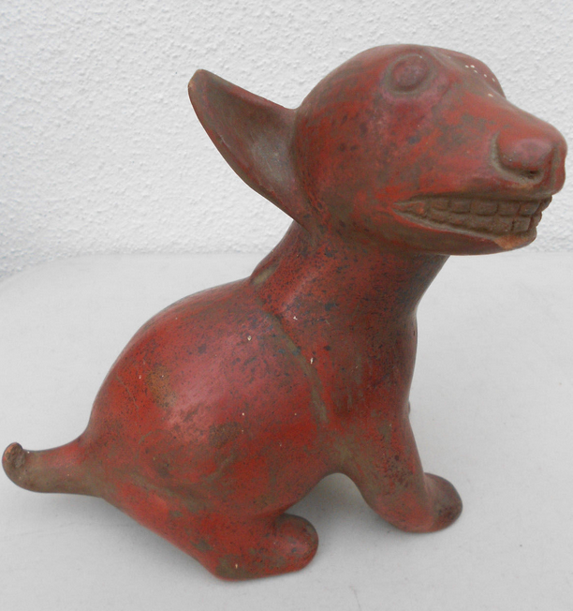

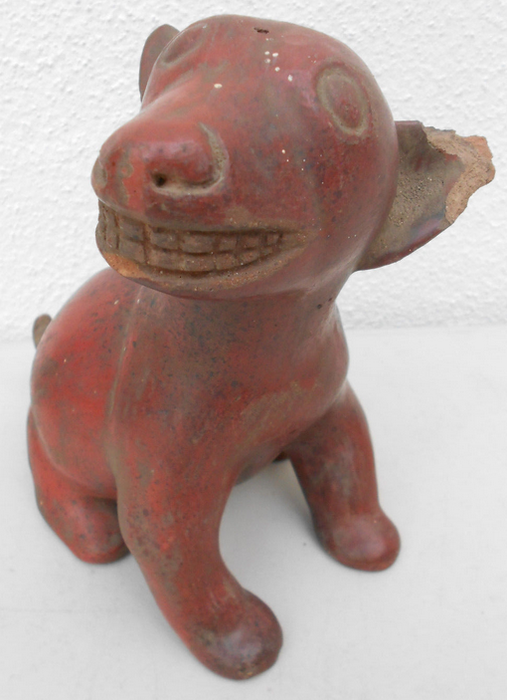 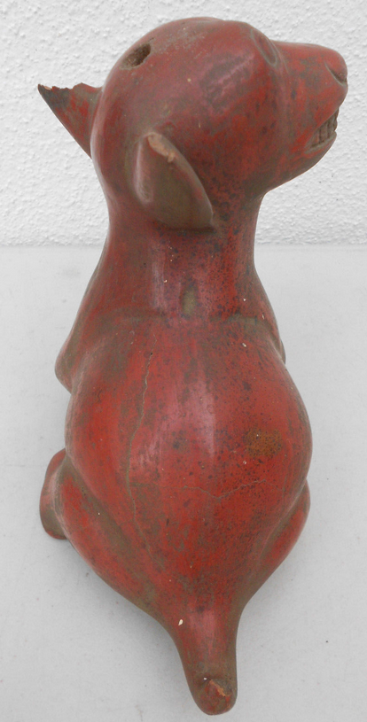

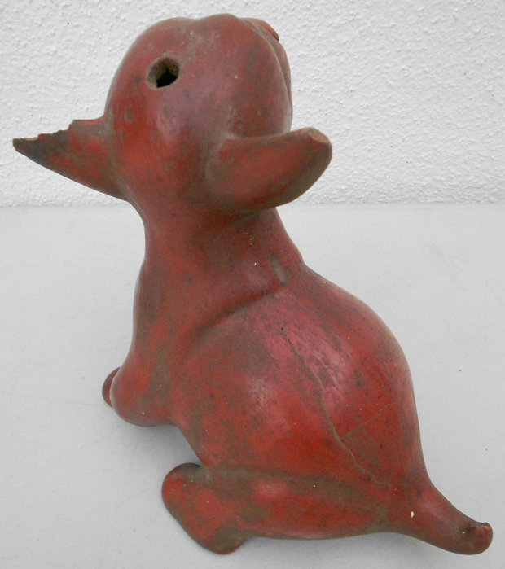 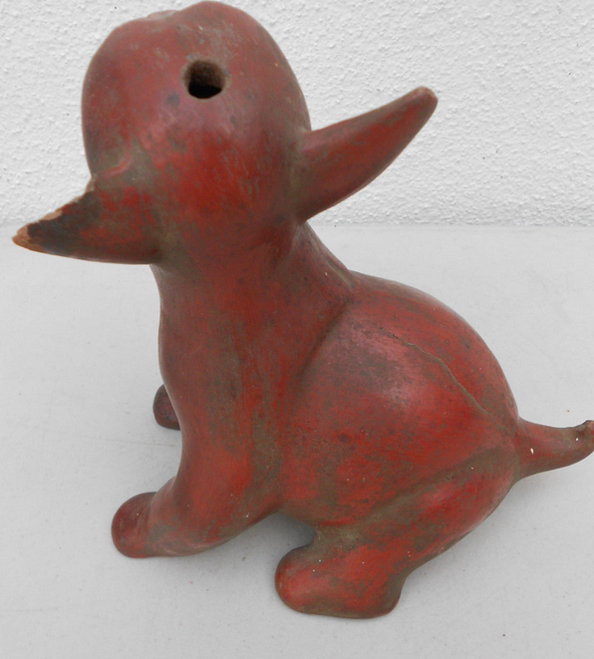 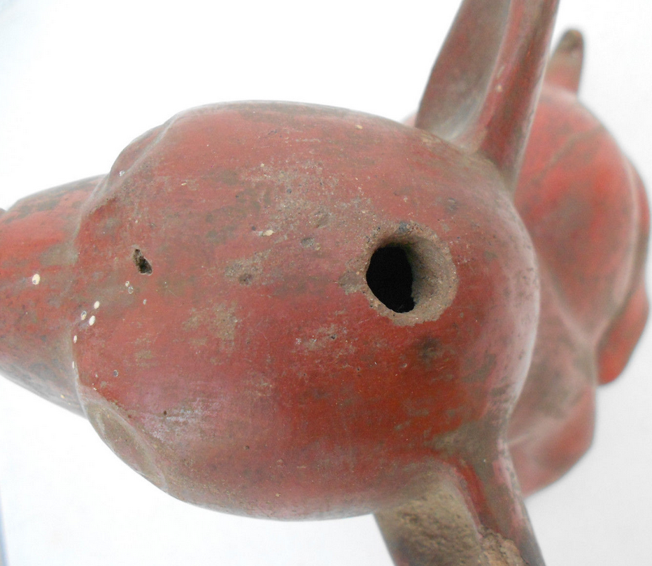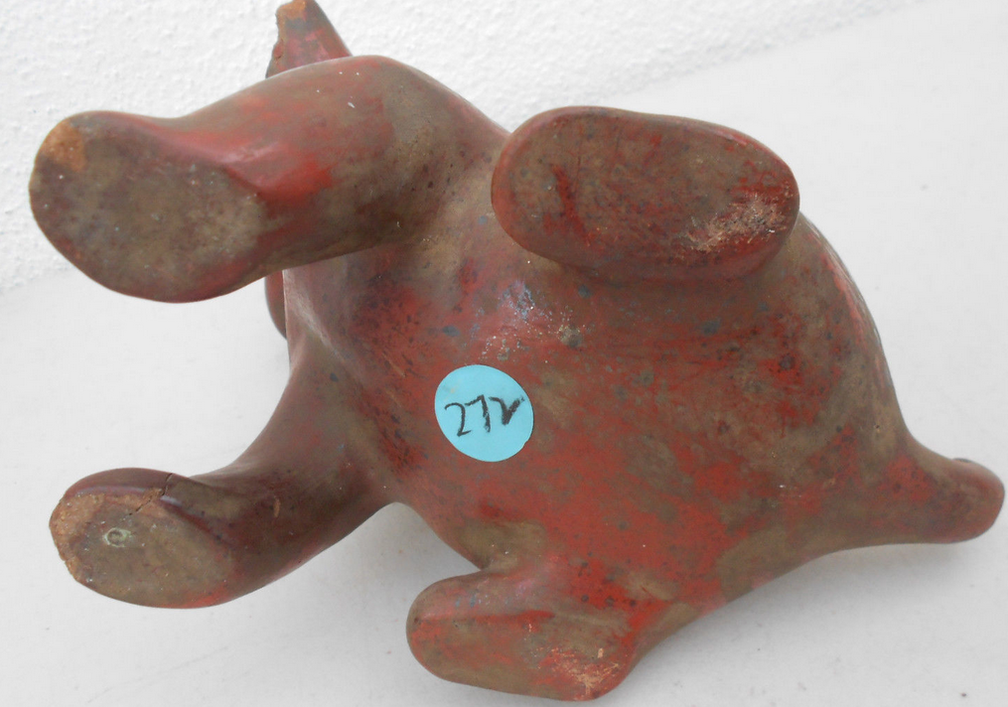 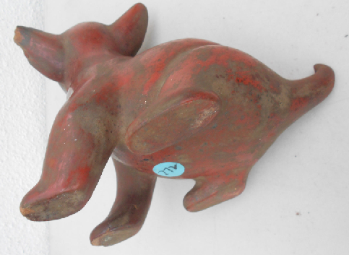 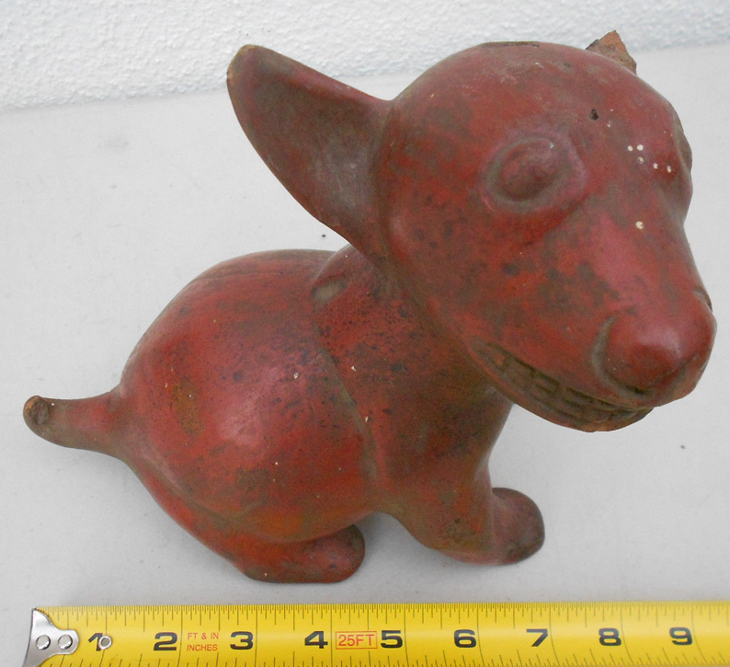 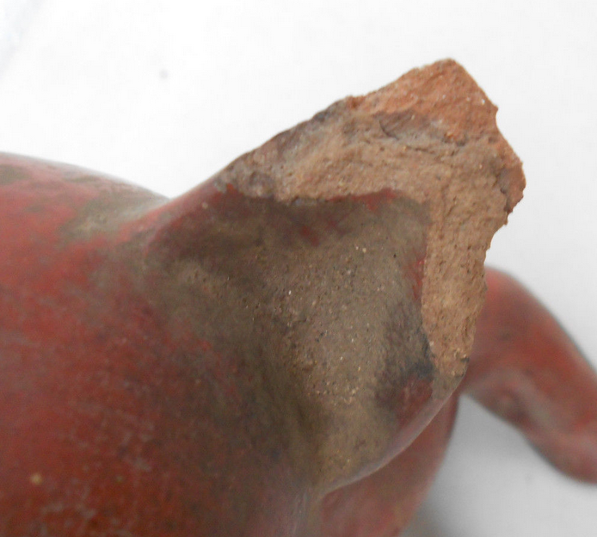

**Case No.: 9**

**Accession No.**

**Formal Label:**

**Display Description:**

The dog is the animal of the dead and therefore of the Place of Shadows (Spence 2015, p. 276). In the Mayan codices, the dog is associated with the god of death, storm, and lightning (Johnson 1994: 118).

In addition to their connection with the dead, the ceramic representations of these dogs often take on a charmingly familiar demeanor as both a pet and as a delicacy, which is often playfully suggested by their exceedingly plump ceramic representations.

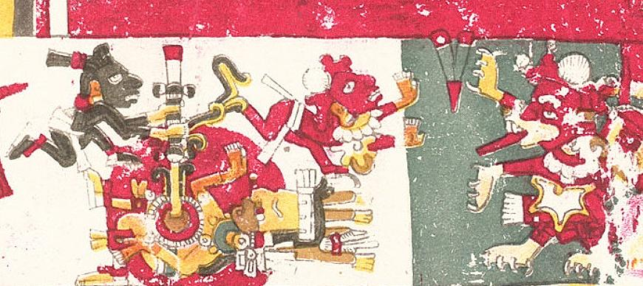

* **LC Classification:** F1219.1.C75

**Date or Time Horizon: 300 BCE-300 CE**

**Geographical Area: W Mexico**

**Map:**

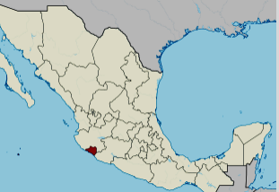

**Location of Colima, Mexico. https://upload.wikimedia.org/wikipedia/commons/thumb/a/a6/Colima_in_Mexico_%28location_map_scheme%29.svg/375px-Colima_in_Mexico_%28location_map_scheme%29.svg.png**

**GPS coordinates:** [19°10′N 103°53′W](https://tools.wmflabs.org/geohack/geohack.php?pagename=Colima&params=19_10_N_103_53_W_type:adm1st_region:MX)

**Cultural Affiliation: Colima**

**Medium: terra cotta**

**Dimensions:** 6" high

**Weight:**

**Condition:** original

**Provenance:** Originally deposited in a shaft tomb. Recovered from the ancient Colima culture in Western Mexico prior to 1970.

**Discussion:**

The Colima believed dogs were mythic emissaries of Xolotl, the Aztec god of the dead. Colima dogs were patterned after a hairless variety of ancient dog known as **Xoloitzcuintli,** from the god Xolotl and *itzcuīntli*, meaning “dog” in Nahuatl (*Nahuatl Dictionary* 1997). Xolotl, with his dog, were believed to be both guides of the Sun as it traveled through the underworld every night and guides of the spirits of the dead to their resting place in the underworld. In life **Xoloitzcuintli** dogs are a tawny gray but in myth they are a bright burnished vermilion. The color red is a clue to their Mesoamerican mythological heritage as is seen in the Codex Borgia (p. 34, below). Within the sanctuary of the Red Temple, the Sun is finally born. A warrior drills a fire on the chest of a figure lying down with the solid red disk of the solar deity in the background. Immediately to the right, the deity is enthroned in his temple. He now has canine claws, a canine maw, the wind jewel, and a distended eye that identify him as the *red* Xolotl. As the solar guide, he now carries the Sun on his back (Boone 2013). Xolotl is represented as a *red* dog, and is distinguished as the deity of air and of the four directions of the wind. His twin is Quetzalcoatl, and both are the sons of the virgin Coatlicue, the Aztec goddess who gave birth to the moon, stars, and Huitzilopochtli, the god of the Sun. Since twins in Mesoamerica were considered unnatural, one was usually sacrificed. The sacrificed twin in this case was Xolotl, and he was portrayed as a dog with the belief that dogs accompanied the souls of the dead to Mictlan, the underworld of Aztec mythology, while his surviving brother, Quetzalcoatl, “The Precious Surviving Twin,” dwells in the light of the Sun (Maffie 2013).

**References:**

Boone, Elizabeth Hill (2007). Cycles of Time and Meaning in the Mexican Books of Fate. Austin: University of Texas Press.

Coe, Sophie D. (1994) *America's first cuisines.* Austin: University of Texas Press, 1994.

Johnson, Buffie (1994). Lady of the Beasts: The Goddess and Her Sacred Animals. Inner Traditions International.

Maffie, James (2015). Aztec Philosophy: Understanding a World in Motion. University Press of Colorado

Milbrath, Susan (2013). Heaven and Earth in Ancient Mexico: Astronomy and Seasonal Cycles in the Codex Borgia. Austin: University of Texas Press.

*Nahuatl Dictionary.* (1997). Wired Humanities Project. University of Oregon.

# Seler, Eduard (1904). Mexican And Central American Antiquities, Calendar Systems And History. translated by Charles P. Bowditch. Mexican and Central American Antiquities, Calendar System and History (Smithsonian Institution / Bureau of Ethnology, Bulletin No. 28) Washington: Government Printing Office.